**E-PROJECT DOCUMENTATION**



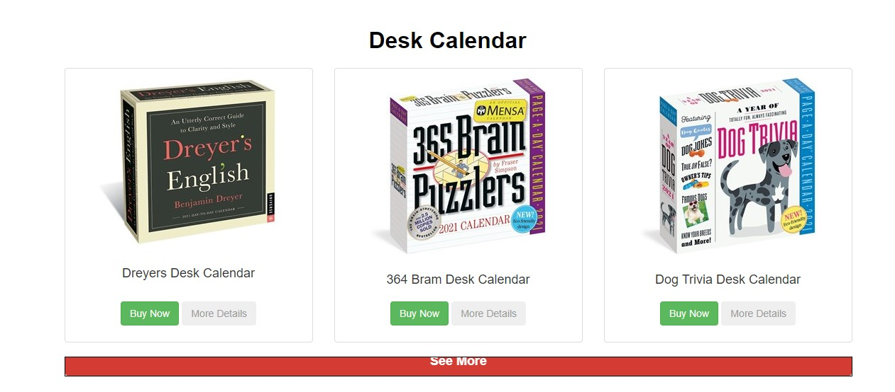

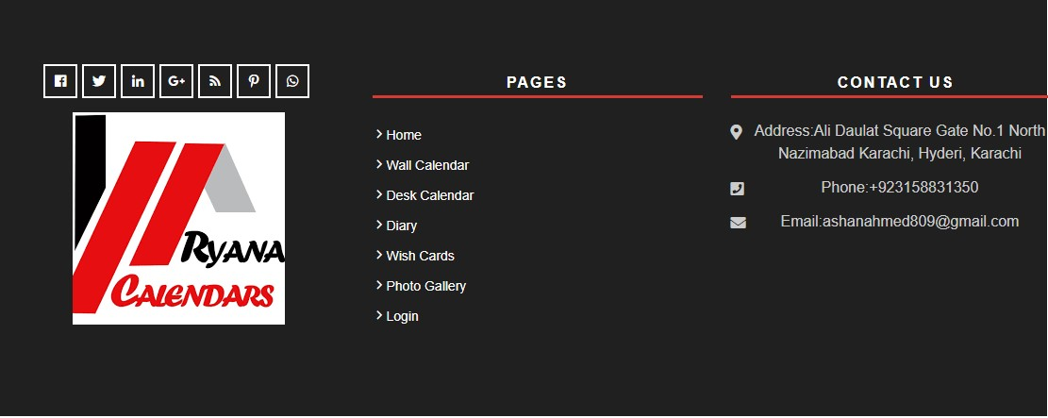

INDEX

* **Home Page**
* **Product Pages**
  + **Wish card**
  + **Calendars**
  + **Diaries**
* **Gallery Page**
* **Login Page**



**Faculty: OWAIS KHAN**

**batch code: <2009G1>**

**NAVBAR**



**CODE**

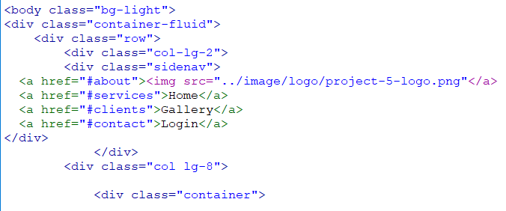

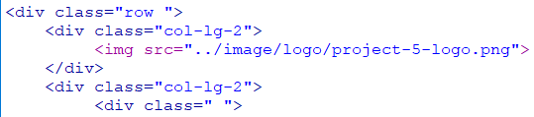

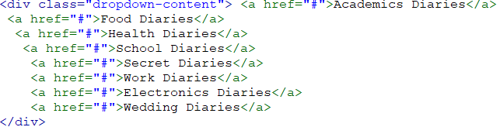

RYANA CALENDARS





